OUTPUTS
In this file , output of each code block is shown.
- Main menu
main()

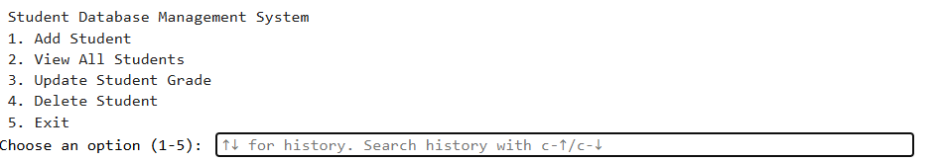

- Adding record of any student .
add_student()

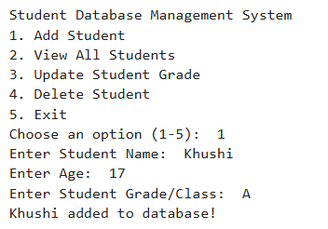

- Viewing data of all students.
view_students()
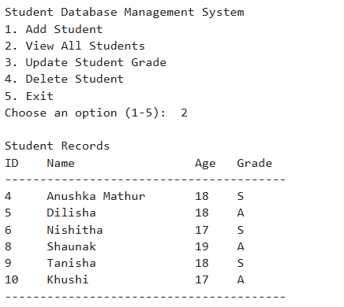

- Updating data of any student.
Update_student()
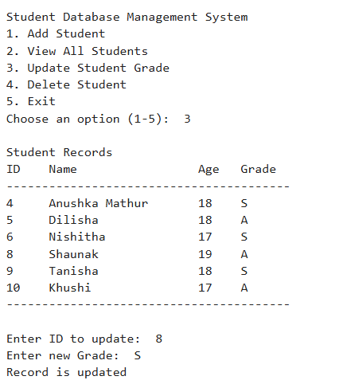
- Deleting record of any student.
delete_student()
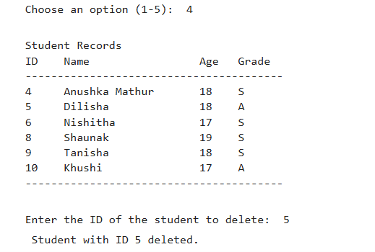

- Entering value other than (1-5).
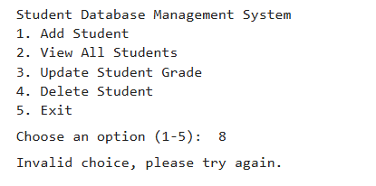

- Exiting the program.
